**Project 2 – Wen Lin**

|  |
| --- |
| Project Title |
| **What should I get from McDonalds?** |

­­­­­­­­­­

**Day 1 (Today)**  
**Between now and Tuesday, you will need to start brainstorming topics with your group and researching potential data sets. Your focus should center around:**

* Selecting a topic – **What to eat at McDonald’s? (calories calculator)**
* Finding a data set – K**aggle (all menu items + nutrition facts)**
* Finding inspiration – We all want to eat healthy and indulge occasionally.

**Day 2**  
**You will need to create a 1-page proposal that includes:**

* A brief articulation of your chosen topic and rationale

**Users input basic information such as Age & Sex & how many meals they eat per day, in order to retrieve recommended meals under recommended calories intake based on USDA.**

* A link to your data set(s) and a screenshot of the metadata if it exists.

<https://www.kaggle.com/mcdonalds/nutrition-facts>

* 3 or 4 screenshots of relevant, “inspiring” visualizations that inspire your project

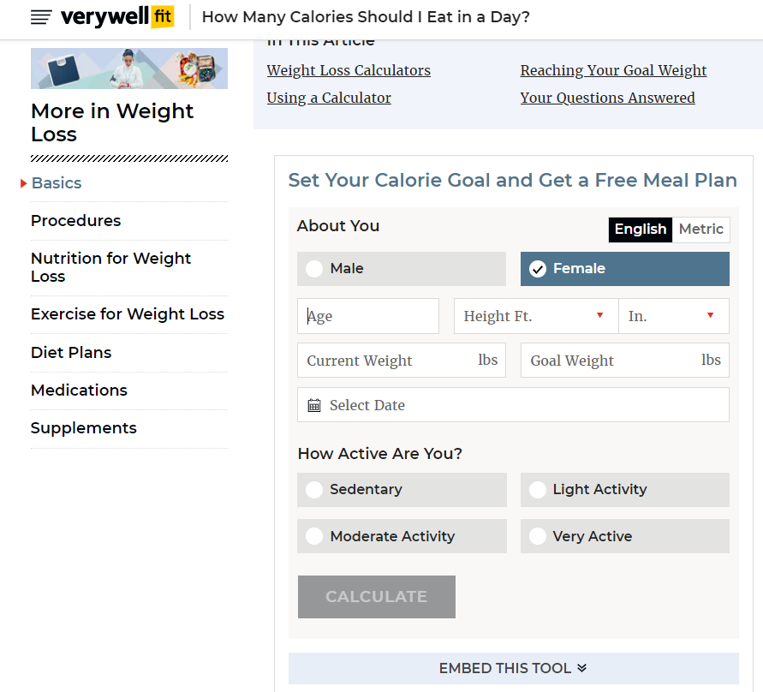

* A link to the primary GitHub repository you’ll be housing your work in:  
  <https://github.com/stevewenlin/project2>

**Project Description**

1. Your task is to tell a story through data visualizations
2. Focus on providing users an interactive means to explore data themselves
3. Prepare a 10 minute presentation that lays out your theme, code approach, data munging techniques and final visualizations
4. You may choose a project of any theme, but I challenge you to not use a topic you’ve done in the past
5. You will have ample time in class to work with your group, but expect to put in hours outside of class as well.

**Specific Requirements**

1. Your visualization must include a Python Flask–powered RESTful API, HTML/CSS, JavaScript, and at least one database (SQL, MongoDB, SQLite, etc.).
2. Your project should fall into one of the below four tracks:
   * A custom “creative” D3.js project (i.e., a nonstandard graph or chart)
   * A combination of web scraping and Leaflet or Plotly
   * A dashboard page with multiple charts that update from the same data
   * A “thick” server that performs multiple manipulations on data in a database prior to visualization (**must be approved**)
3. Your project should include at least one JS library that we did not cover.
4. Your project must be powered by a data set with at least 100 records.
5. Your project must include some level of user-driven interaction (e.g., menus, dropdowns, textboxes).
6. Your final visualization should ideally include at least three views.